Ground Floor Commercial Unit
To Let
11 Market Street Bangor BT20 4SP

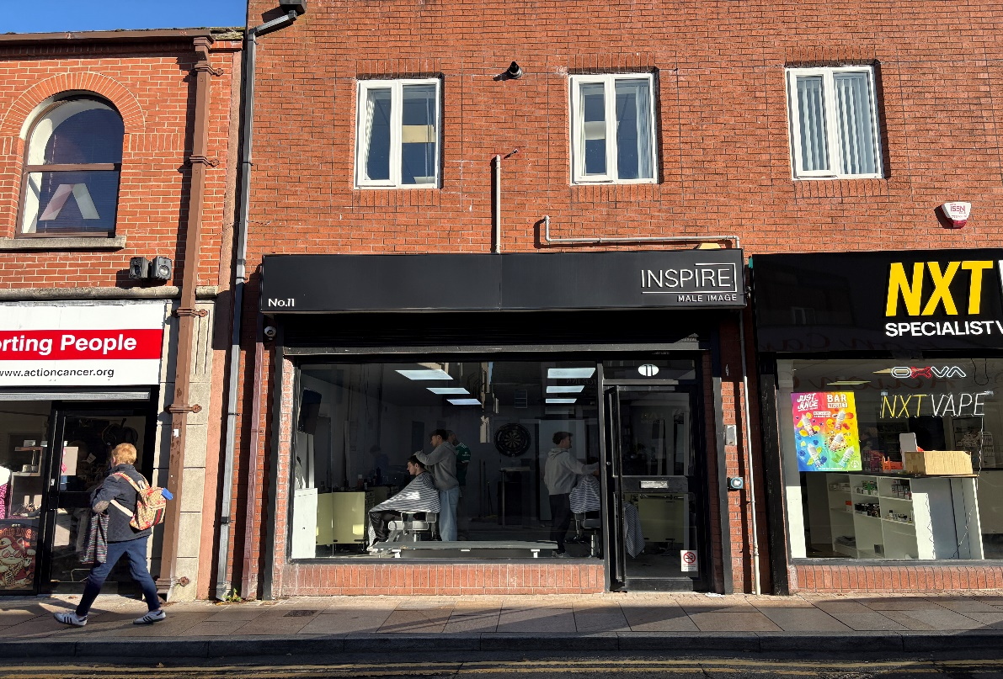
Key Features:
- Central location just off Main Street in Bangor Town Centre
- Ground floor accommodation which extends to 425 Sq Ft
- Suitable for a variety of commercial uses, subject to any statutory planning consents.

LOCATION
The subject premises is located on Market Street, which is accessed via Main Street in Bangor Town Centre, Nearby occupiers include Menarys, Action Cancer, Caskie Opticians, Curious Candy Sweet Shop, Custom Hair

DESCRIPTION
Finished to an excellent standard and available for occupation on the 8th August 2026, the premises provide well-presented accommodation comprising a generous sales area, private office/store, kitchen, and WC facilities. Specification highlights include a suspended ceiling with integrated fluorescent strip lighting, vinyl flooring, and an electric roller shutter securing the frontage.

ACCOMODATION
We calculate the approximate gross internal area to be approximately 425 Sq ft.

LEASE
Length of lease by negotiation

RATES
NAV: £5,050
Non-Domestic Rate in £ (26-27): 0.609456
Rates Payable: £3,077.75 per annum

Please note, this property should be eligible for a 20% reduction in rates payable due to Small Business Rates Relief.
We recommend that you contact Land & Property Services to verify these figures (Tel: 0300 200 7801).

RENT
Inviting offers in the region of £9,500 per annum.

SERVICE CHARGE
Tenant to be responsible for the payment of a Service Charge in connection with
the upkeep, maintenance, repair and decoration of the building of which the
subject premises form’s part, to include a proportion of the building insurance
and agents’ management fees, which are calculated at 5% plus VAT of the
annual rent.

VAT
All figures quoted are exclusive of VAT, which we understand is payable.

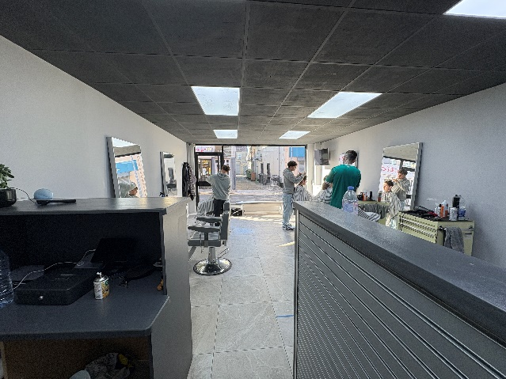

For further information please contact:
Brian Kidd
07885 739063
bkidd@frazerkidd.co.uk
Beth Brady
0775924283
bbrady@frazerkidd.co.uk
Telfair House, 87/89 Victoria Street, Belfast, BT1 4PB
028 9023 3111
mail@frazerkidd.co.uk
frazerkidd.co.uk

Disclaimer
Frazer Kidd Property Limited for themselves and for the vendors of this property whose agents they are, give notice that (I) The particulars are set out as a general outline for the guidance of intending purchasers or lessees, and do not constitute part of an offer or contract; (ii) All descriptions, dimensions, references to condition and necessary permissions for use and occupation, and other details are given in good faith and are believed to be correct, but any intending purchasers or tenants should not rely on them as statements or representations of fact but must satisfy themselves by inspection or otherwise as to the correctness of each of them; (Iii) No person in employment of Frazer Kidd Property Limited has any authority to make or give representations or warranty whatever in relation to this property.
As a business carrying out estate agency work when we enter into a relationship with a customer, we are required, if applicable, to verify the identity of both vendor and purchaser as outlined in the Money Laundering, Terrorist Financing and Transfer of Funds (information on the payer) Regulations 2017 – http://www.legislation.gov.uk/uksi/2017/692/made. In accordance with legislation, any information and documentation provided by you will be held for a period of five years from when you cease to have a contractual relationship with Frazer Kidd Property Limited. The information will be held in accordance with the General Data Protection Regulations (GDPR) and will not be passed on to any other party unless we are required to do so by law.

